**2.4.1: SAS - Simultaneous Inference and Regression Through Origin**

Dr. Bean – Stat 5100

/********************************************************/

/* Input Toluca data (recall Ch. 1 example) */

**data** toluca; input lotsize workhours @@; cards;

80 399 30 121 50 221 90 376 70 361 60 224

120 546 80 352 100 353 50 157 40 160 70 252

90 389 20 113 110 435 100 420 30 212 50 268

90 377 110 421 30 273 90 468 40 244 80 342

70 323

;

**run**;

/* Simultaneous 95% interval estimation of betas */

**proc** **reg** data=toluca;

model workhours = lotsize / clb alpha=**.025**;

title1 'Simultaneous 95% confidence intervals on betas';

**run**;

|  |  |  |  |  |  |  |  |  |  |  |  |  |  |  |  |  |  |  |  |  |  |  |  |  |  |  |  |  |  |  |  |  |  |
| --- | --- | --- | --- | --- | --- | --- | --- | --- | --- | --- | --- | --- | --- | --- | --- | --- | --- | --- | --- | --- | --- | --- | --- | --- | --- | --- | --- | --- | --- | --- | --- | --- | --- |
| |  | | --- | | ***Simultaneous 95% confidence intervals on betas*** |      | **Parameter Estimates** | | | | | | | | | --- | --- | --- | --- | --- | --- | --- | --- | | **Variable** | **DF** | **Parameter Estimate** | **Standard Error** | **t Value** | **Pr > |t|** | **97.5% Confidence Limits** | | | **Intercept** | **1** | 62.36586 | 26.17743 | 2.38 | 0.0259 | -0.40436 | 125.13607 | | **lotsize** | **1** | 3.57020 | 0.34697 | 10.29 | <.0001 | 2.73821 | 4.40220 | |

**/* Simultaneous 90% interval estimation of mean workhours**

**at lotsize levels 30, 65, 100 (using Working-Hotelling**

**and Bonferroni)**

**\*/**

**data dummy; input lotsize check; cards;**

**30 1**

**65 1**

**100 1**

**;**

**data temp; set toluca dummy;**

**proc reg data=temp noprint;**

**model workhours = lotsize;**

**output out=out1 p=Yhat stdp=seYhat;**

**/* KEY: stdp is SE of mean prediction */**

**data out1; set out1;**

**alpha = 0.10; /* 1-alpha is simult. conf. level */**

**p = 2; /* # of beta's (including intercept) */**

**n = 25; /* sample size */**

**g = 3; /* number of simultaneous intervals */**

**W = sqrt(p*finv(1-alpha,p,n-p)); /* WH crit. val. */**

**t = tinv(1-alpha/(2*g),n-p); /* Bonf. crit. val. */**

**WH_upper = Yhat + W*seYhat;**

**WH_lower = Yhat - W*seYhat;**

**B_upper = Yhat + t*seYhat;**

**B_lower = Yhat - t*seYhat;**

**proc print data=out1;**

**where check = 1;**

**var lotsize Yhat seYhat WH_lower WH_upper**

**B_lower B_upper;**

**title1**

**'Simultaneous 90% interval estimation of mean response';**

**title2**

**'at three X-levels, using Working-Hotelling and**

**Bonferroni';**

**run;**

|  |  |  |  |  |  |  |  |  |  |  |  |  |  |  |  |  |  |  |  |  |  |  |  |  |  |  |  |  |  |  |  |  |  |  |
| --- | --- | --- | --- | --- | --- | --- | --- | --- | --- | --- | --- | --- | --- | --- | --- | --- | --- | --- | --- | --- | --- | --- | --- | --- | --- | --- | --- | --- | --- | --- | --- | --- | --- | --- |
| |  | | --- | | ***Simultaneous 90% interval estimation of mean response*** | | ***at three X-levels, using Working-Hotelling and Bonferroni*** |  | **Obs** | **lotsize** | **Yhat** | **seYhat** | **WH_lower** | **WH_upper** | **B_lower** | **B_upper** | | --- | --- | --- | --- | --- | --- | --- | --- | | **26** | 30 | 169.472 | 16.9697 | 131.154 | 207.790 | 131.057 | 207.887 | | **27** | 65 | 294.429 | 9.9176 | 272.035 | 316.823 | 271.978 | 316.880 | | **28** | 100 | 419.386 | 14.2723 | 387.159 | 451.613 | 387.077 | 451.695 | |

**/* Simultaneous 95% prediction limits on next two lots,**

**with sizes 80 and 100 units (using Scheffe and**

**Bonferroni)**

**\*/**

**data dummy; input lotsize check; cards;**

**80 1**

**100 1**

**;**

**data temp; set toluca dummy;**

**proc reg data=temp noprint;**

**model workhours = lotsize;**

**output out=out1 p=Yhat stdi=seYhatnew;**

**/* KEY: stdi is SE of individual prediction */**

**data out1; set out1;**

**alpha = 0.05; /* 1-alpha is simult. pred. level */**

**p = 2; /* # of beta's (including intercept) */**

**n = 25; /* sample size */**

**g = 2; /* number of simultaneous intervals */**

**S = sqrt(g*finv(1-alpha,g,n-p)); /* Scheffe crit val */**

**t = tinv(1-alpha/(2*g),n-p); /* Bonf. crit. val. */**

**S_upper = Yhat + S*seYhatnew;**

**S_lower = Yhat - S*seYhatnew;**

**B_upper = Yhat + t*seYhatnew;**

**B_lower = Yhat - t*seYhatnew;**

**proc print data=out1;**

**where check = 1;**

**var lotsize Yhat seYhatnew S_lower S_upper**

**B_lower B_upper;**

**title1 'Simultaneous 95% interval estimation of**

**individual prediction';**

**title2 'at two X-levels, using Scheffe and Bonferroni';**

**run;**

|  |  |  |  |  |  |  |  |  |  |  |  |  |  |  |  |  |  |  |  |  |  |  |  |  |  |  |
| --- | --- | --- | --- | --- | --- | --- | --- | --- | --- | --- | --- | --- | --- | --- | --- | --- | --- | --- | --- | --- | --- | --- | --- | --- | --- | --- |
| |  | | --- | | ***Simultaneous 95% interval estimation of individual prediction*** | | ***at two X-levels, using Scheffe and Bonferroni*** |  | **Obs** | **lotsize** | **Yhat** | **seYhatnew** | **S_lower** | **S_upper** | **B_lower** | **B_upper** | | --- | --- | --- | --- | --- | --- | --- | --- | | **26** | 80 | 347.982 | 49.9110 | 217.407 | 478.557 | 228.302 | 467.662 | | **27** | 100 | 419.386 | 50.8666 | 286.311 | 552.461 | 297.414 | 541.358 | |

**/********************************************************/**

**/* Regression through origin example: plumbing supplies**

**company looking at relationship between number of**

**work units (X) and labor costs (Y) at its 12 warehouses**

**\*/**

**data warehouse; input work cost @@; cards;**

**20 114 196 921 115 560 50 245 122 575 100 475**

**33 138 154 727 80 375 147 670 182 828 160 762**

**0 .**

**;**

**proc reg data=warehouse;**

**model cost = work / noint;**

**output out=out1 p=pred;**

**title1 'Regression through origin';**

**run;**

|  |  |  |  |  |  |  |  |  |  |  |  |  |  |  |  |  |  |  |  |  |  |  |  |  |  |  |  |  |  |  |  |  |  |  |  |  |  |  |  |  |  |  |  |  |  |  |  |  |  |  |  |  |  |  |  |  |  |  |  |  |  |  |  |  |  |  |  |  |  |
| --- | --- | --- | --- | --- | --- | --- | --- | --- | --- | --- | --- | --- | --- | --- | --- | --- | --- | --- | --- | --- | --- | --- | --- | --- | --- | --- | --- | --- | --- | --- | --- | --- | --- | --- | --- | --- | --- | --- | --- | --- | --- | --- | --- | --- | --- | --- | --- | --- | --- | --- | --- | --- | --- | --- | --- | --- | --- | --- | --- | --- | --- | --- | --- | --- | --- | --- | --- | --- | --- |
| |  | | --- | | ***Regression through origin*** |  |  |  | | --- | --- | | **Number of Observations Read** | 13 | | **Number of Observations Used** | 12 | | **Number of Observations with Missing Values** | 1 |      |  |  | | --- | --- | | ***Note:*** | ***No intercept in model. R-Square is redefined.*** |  | **Analysis of Variance** | | | | | | | --- | --- | --- | --- | --- | --- | | **Source** | **DF** | **Sum of Squares** | **Mean Square** | **F Value** | **Pr > F** | | **Model** | 1 | 4191980 | 4191980 | 18762.5 | <.0001 | | **Error** | 11 | 2457.65933 | 223.42358 |  |  | | **Uncorrected Total** | 12 | 4194438 |  |  |  |      |  |  |  |  | | --- | --- | --- | --- | | **Root MSE** | 14.94736 | **R-Square** | 0.9994 | | **Dependent Mean** | 532.50000 | **Adj R-Sq** | 0.9994 | | **Coeff Var** | 2.80702 |  |  |      | **Parameter Estimates** | | | | | | | --- | --- | --- | --- | --- | --- | | **Variable** | **DF** | **Parameter Estimate** | **Standard Error** | **t Value** | **Pr > |t|** | | **work** | **1** | 4.68527 | 0.03421 | 136.98 | <.0001 | |

**proc sort data=out1; by work;**

**proc sgplot data=out1;**

**scatter x=work y=cost /**

**markerattrs=(symbol=CIRCLEFILLED size=2pt);**

**series x=work y=pred / lineattrs=(pattern=solid);**

**xaxis values=(0 to 200 by 50);**

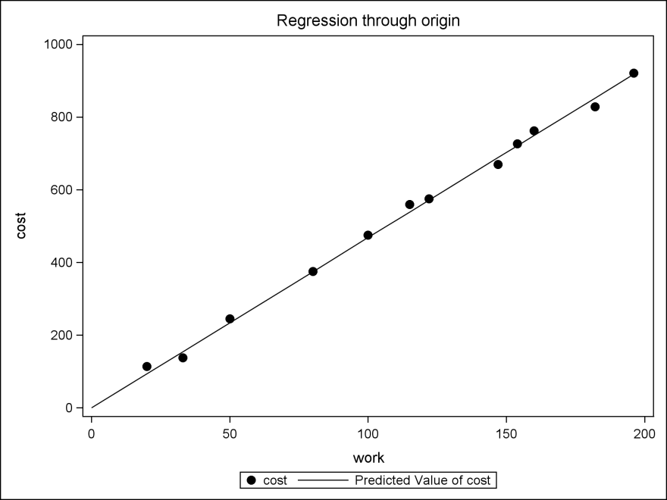 **yaxis values=**

**(0 to 1000 by 200);**

**run;**

**/* Note forced inclusion of**

**work=0 dummy observation**

**for graphical purposes */**